### **Tracing the route from source computer to destination computer**

IP-networks are a bit like postal networks. Instead of envelopes computers send IP-packets to other computers and the network takes care of routing the packets through the network, through many networks.

In this assignment you will use tools that make it possible to find out the route that the IP-packets take from source computer to destination computer.

You learn the following things in this exercise:

* Computers in IP -networks can communicate with each other by sending and receiving **IP -packets**. The recipient can be either in the same or another IP network than the sender.
* Each computer connected to an IP network must have an IP address.
* When the computers are in different IP networks then the packets are routed from the sender’s network to recipient's network through intermediate networks owned by operators. These networks consist of devices called routers and they do the packet routing hop by hop from one router to the next one. Typically, there are 5 - 20 routers between the sender and receiver if they are in different IP-networks.
* What is the operators' role on the Internet and what kind of networks do they have? You can take a more detailed look to some operator’s networks and services.
* How to trace the route that IP-packets take from sender to receiver.

**Assignment activities**

Many Internet service providers offer a so-called **Looking Glass - service** that you can use to trace a route from starting points in the operators' network to a destination address that you provide.

You can find these services e.g. by doing search “*Looking Glass” server.*   
(<https://www.google.com/search?q=%22looking+glass%22+server>)

1. In what country and in which city was the server that you selected as a starting point for your trace. What was your destination in the test.  
     
   Country:kenya   
   City:Mombasa  
   Link to the service: https://lg.he.net   
   Who provides the service?

Destination: https://net.centria.fi

1. How many routers were between the traceroute server and the destination you had selected?  
   Paste also a screen clip of the trace so that the teacher can check your answers.

Number of routers: 12

The trace below is just for example purposes - replace it by your own traceroute output. Many Looking Glass servers require that you give the destination IP-address not a host name. If you don’t know the IP-address you can find it by issuing command *nslookup hostname*. See example below:  
  
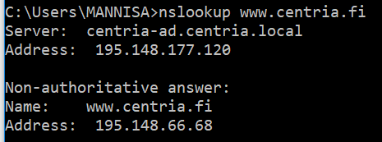

Below is a traceroute result that I got when using Hurricane Electric’s Looking Glass server (<https://lg.he.net/>). From the server’s list of numerous available starting points I selected Nairobi, Kenya. For a destination I selected Centria’ s web-server’s IP-address. **You must use some other destination in your exercise. Select some other starting point too.**

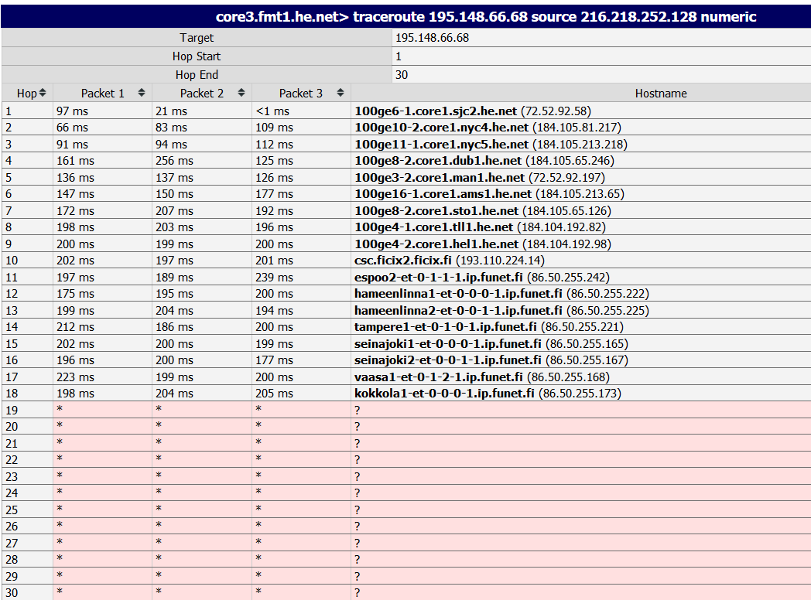

**Note:** Many times, it happens that there is a firewall in the destination that prevents the test IP -packets from entering the company IP-network just like in my trace above. On these occasions we can assume that the last row where the test has succeeded is already in the destination network and you can do your calculation based on the last successful row instead of actual destination. However, it's better if your destination can be reached.   
Taking this into account in my trace above the number of routers between the starting point (216.218.252.128) and [www.centria.fi](http://www.centria.fi) ( 195.148.66.68) was 18 routers.

If you are interested where the destination is located you can use IP geographical location services like <https://db-ip.com/> or <https://iplocation.com/>. Their results are “best guesses”.

1. List at least three operators whose networks were in the path from sender to receiver.   
   You can do this by checking the owner of the router’s IP address (<https://www.ripe.net/>). The IP address in the output rows belong to the intermediate routers in the operator’s network.  
     
   Answer:

Responsible organisation: [CSC - Tieteen tietotekniikan keskus Oy](https://apps.db.ripe.net/db-web-ui/lookup?source=ripe&key=ORG-FF1-RIPE&type=organisation) : 86.50.255.106

[Finnish Communication and Internet Exchange - FICIX ry](https://apps.db.ripe.net/db-web-ui/lookup?source=ripe&key=ORG-Fr4-RIPE&type=organisation) : 193.110.224.14

Responsible organisation: [CSC - Tieteen tietotekniikan keskus Oy](https://apps.db.ripe.net/db-web-ui/lookup?source=ripe&key=ORG-FF1-RIPE&type=organisation) : 86.50.255.242

1. Give an approximate of the time it takes in average from the packets to arrive from the sender to destination?  
   You need to do some study to answer this correctly. Argument your answer.  
     
   I will compute the average RTT by taking the last three values of the final hop

186.654 + 186.363 + 186.513 / 3 = 186.51 ms

Average round trip is 186.5/2 ms = 93.25ms

The time taken for packet to travel in one direction is 93.25ms

1. What was the greatest time difference between two successive routers?  
     
   I took the average RTT and the time to hop from one destination to another

Hope 1 and 2 has the largest increase

1. Was there something odd in your trace?

One packet 3 had a * symbol

1. Try to find out some interesting facts about the operators related to your trace. E.g. how big a network they have, or something related to their history.  
   (Alternatively you can try to find out some facts related to the destination - e.g. the kind of data center where it is located, etc.

CSC – IT Center for Science (Tieteen tietotekniikan keskus Oy)

CSC is a non-profit state enterprise owned by the Finnish government and higher education institutions. Established in 1971, it provides IT support, modeling, computing, and information services for academia, research institutes, and companies in Finland. It even manages the Funet network and data centers in Finland